***Project management tool***

**EPIC**

[[DEMO-1] NetBanking App - Jira (atlassian.net)](https://nehajain3027.atlassian.net/browse/DEMO-1)

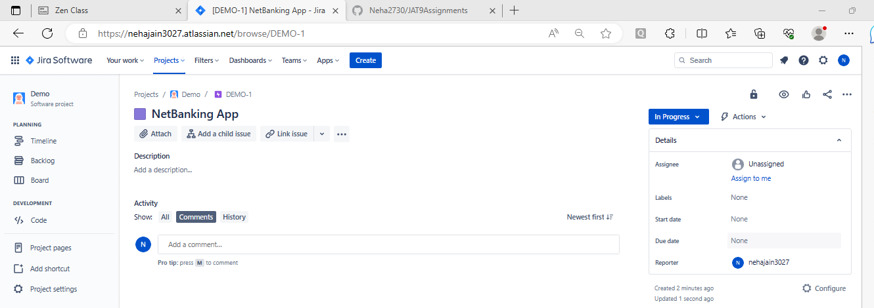

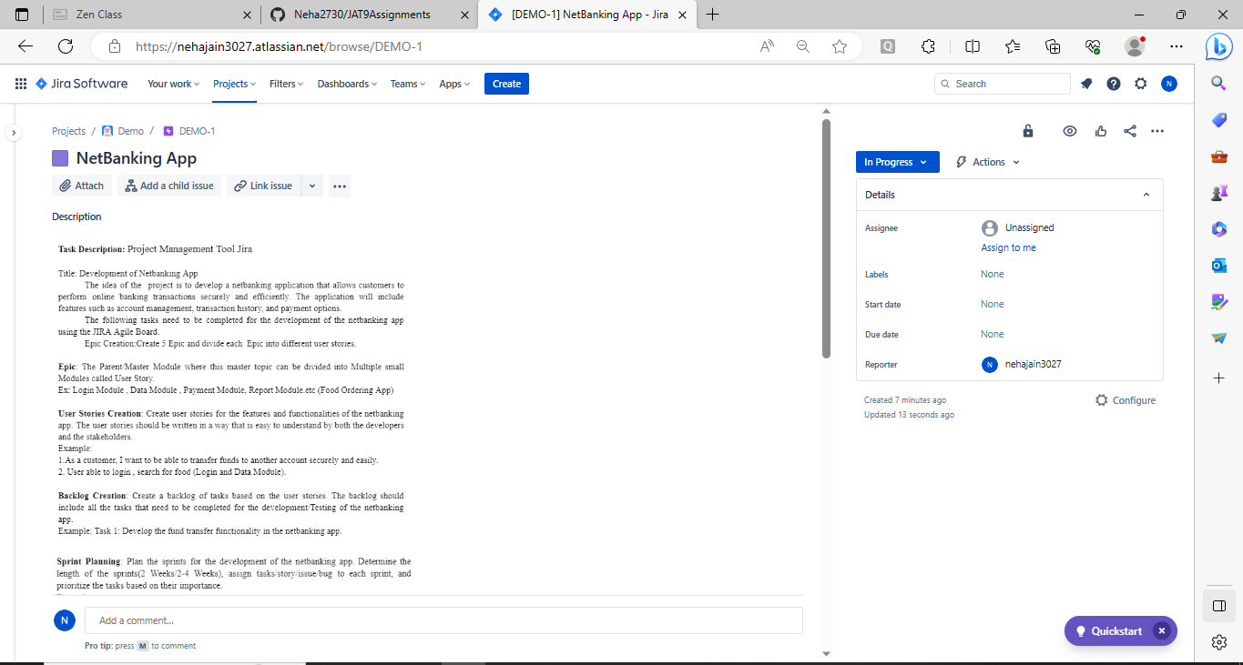

**User Stories**

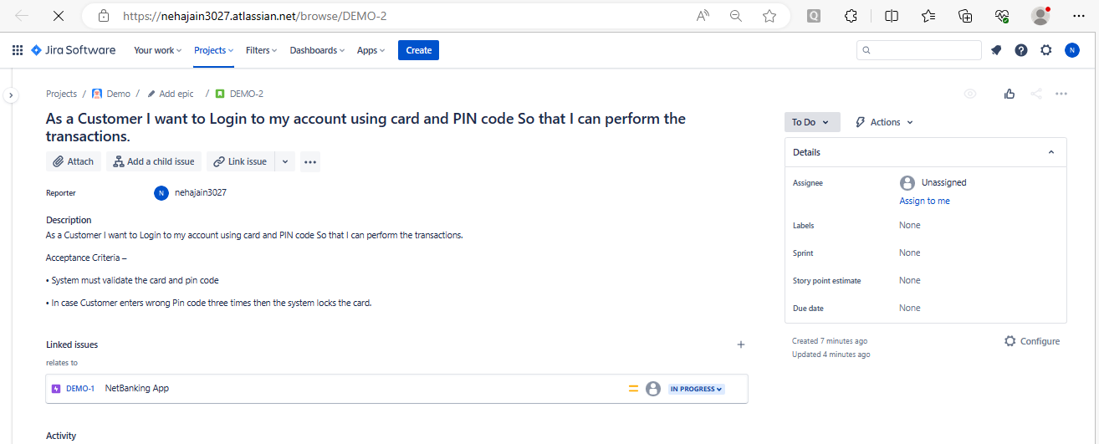

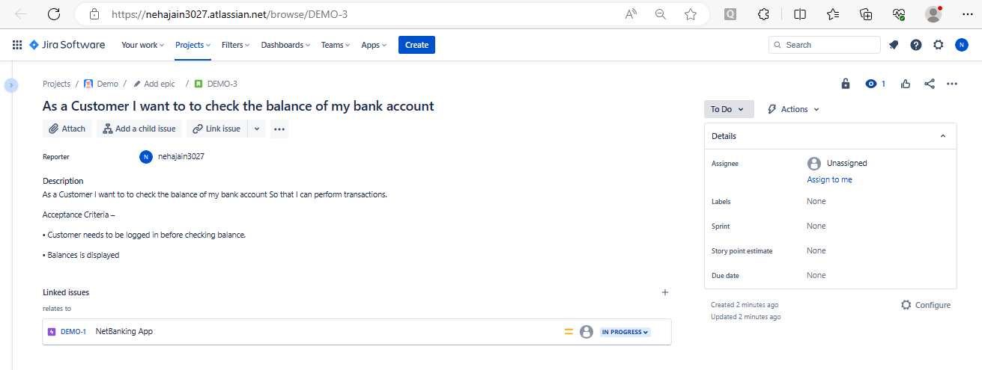

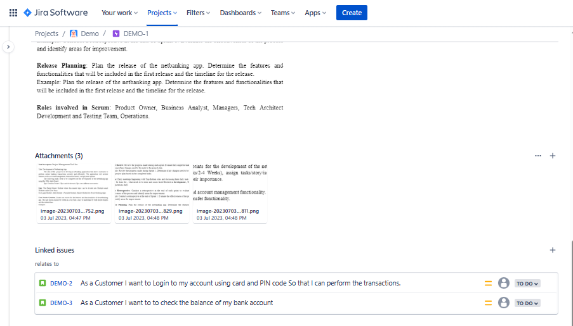

**Test Scenarios**

1. As a Customer  
   I want to Login to my account using card and PIN code  
   So that I can perform the transactions.  
   Acceptance Criteria –  
   • System must validate the card and pin code  
   • In case Customer enters wrong Pin code three times then the system locks the card.
2. As a Customer  
   I want to to check the balance of my bank account  
   So that I can perform transactions.  
   Acceptance Criteria –  
   • Customer needs to be logged in before checking balance.  
   • Balances is displayed.
3. As a Customer  
   I want to to deposit cash in my bank account through ATM  
   So that I may save my time and perform transactions later.  
   Acceptance Criteria –  
   • Customer needs to be logged in before depositing cash.  
   • System should verify the amount of cash deposited by checking with the user.  
   • If the user doesn’t agree then the system ejects back the cash.  
   • If Ok the account balance is updated and displayed.
4. As a Customer  
   I want to to deposit check in my bank account through ATM  
   So that I may save my time and perform transactions later.  
   Acceptance Criteria –  
   • Customer needs to be logged in before depositing check.  
   • System should verify the amount written on the deposited check by asking the user.  
   • If the user doesn’t agree then the system ejects back the check.  
   • If Ok the account balance is updated and displayed.
5. As a Customer  
   I want to withdraw cash from my bank account through ATM  
   So that I may save my time.  
   Acceptance Criteria –  
   • Customer needs to be logged in before withdrawing cash.  
   • System checks to see if the request amount exceeds the balance  
   • If so the system displays the balance and asks the user to enter a new amount.  
   • If amount entered is less than the account balance cash is dispensed and the new  
   balance is displayed.
6. As a Customer  
   I want to transfer money from my account to another bank account through ATM  
   So that I may save my time.  
   Acceptance Criteria –  
   • Customer needs to be logged in before transferring amount.  
   • System should check the receivers account number and validate it prior to performing  
   the transactions.  
   • If Ok the local account balance is updated and displayed.  
   • System should update both accounts concurrently.
7. As a Customer  
   I want to logout from my bank account through ATM  
   So that I may end up my ATM session.  
   Acceptance Criteria –  
   • System asks user if the user wants session report and receipt for the entire session.  
   • If yes then the receipt is dispensed  
   • User is logged off from the account